**30 succefull turns:**

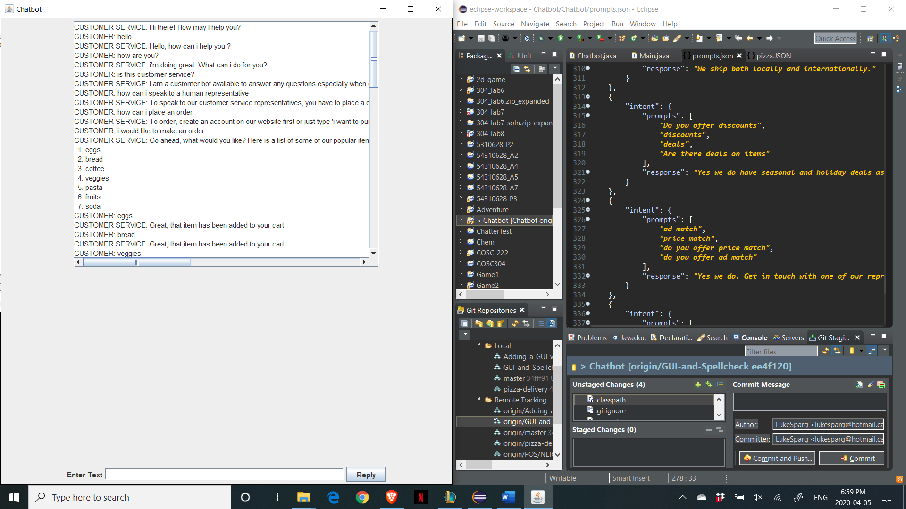

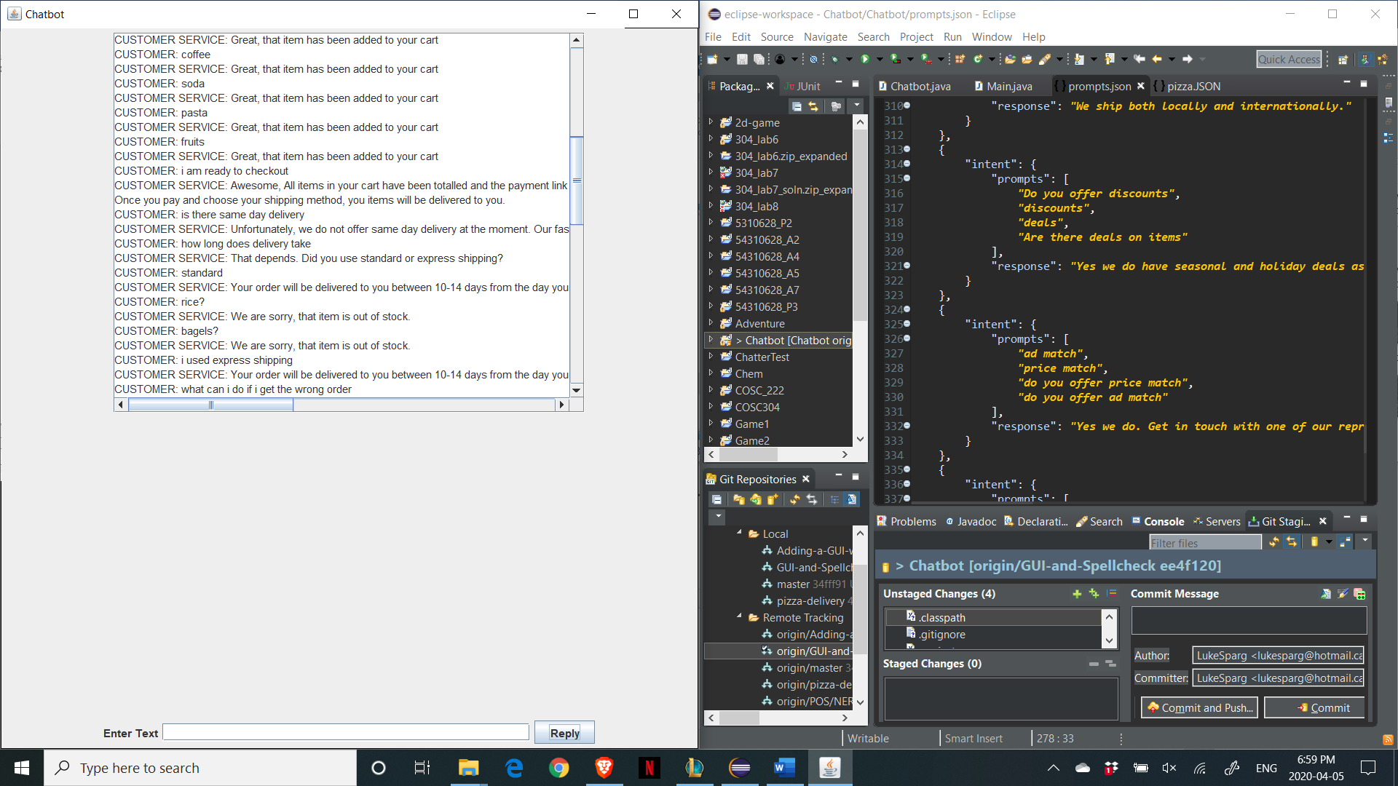

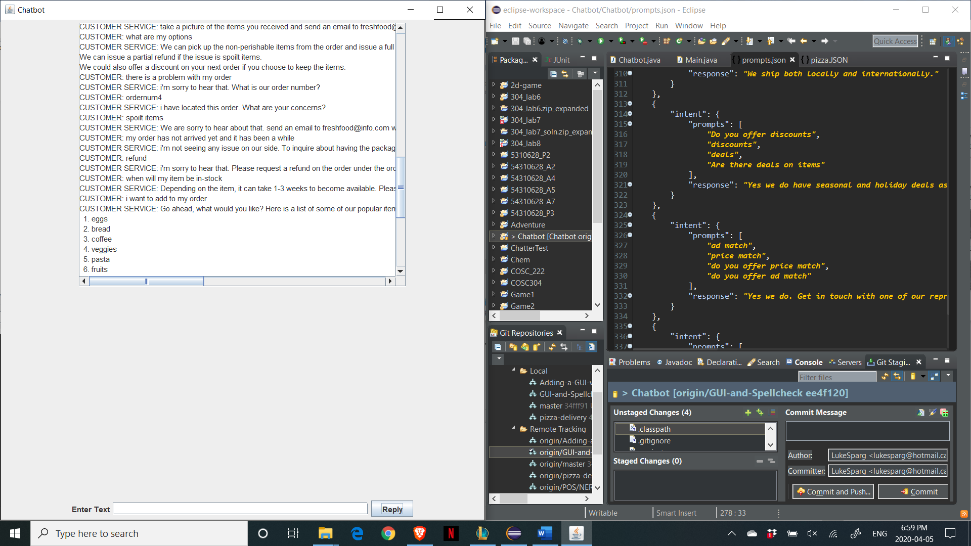

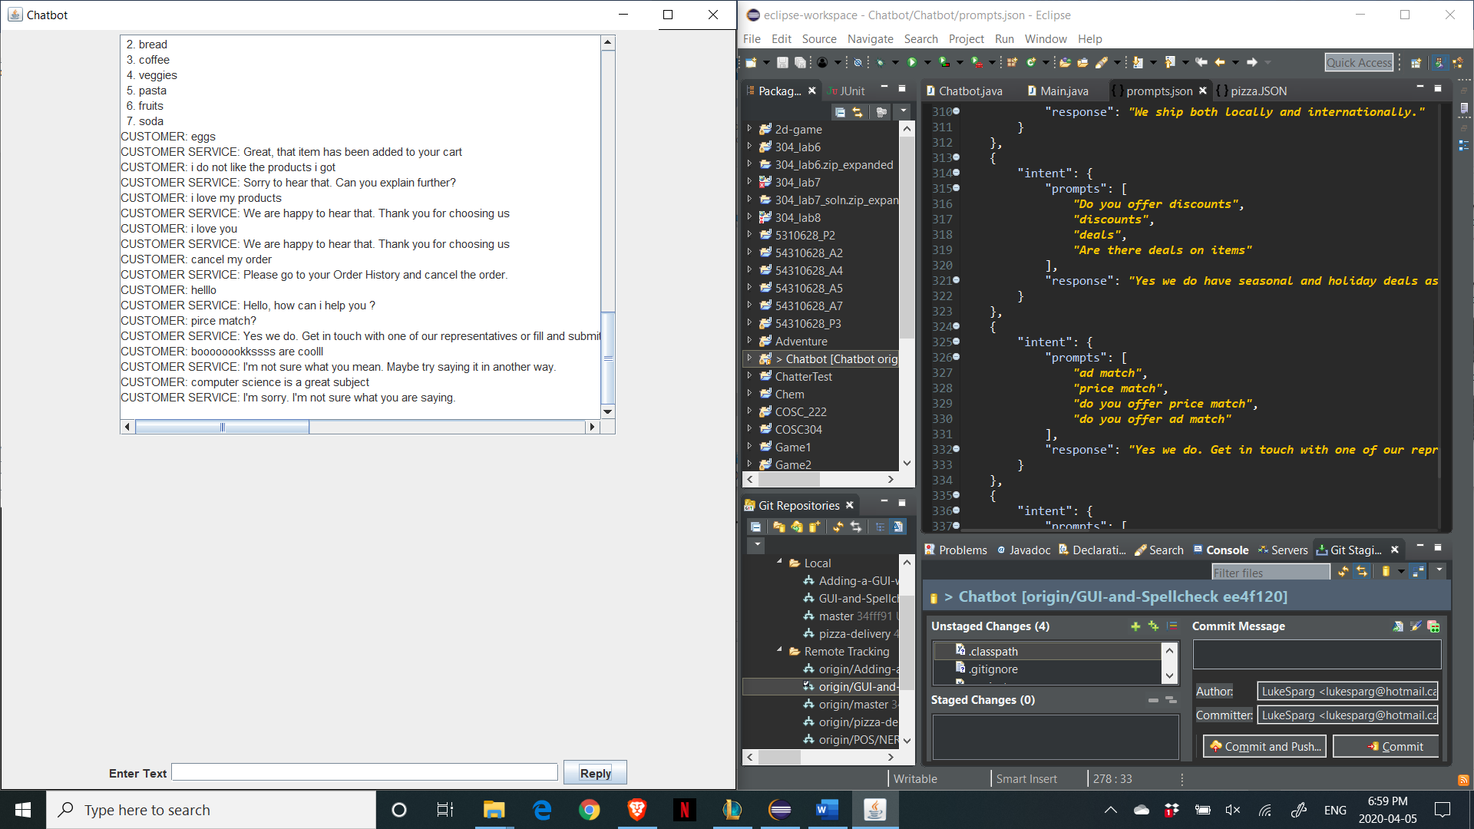

**Times when the program behaves erratically:**

The bot has trouble when it does not understand what the user it trying to say as input or when the bot misinterprets what you are saying as something else.

When it misinterprets what you are trying to say:

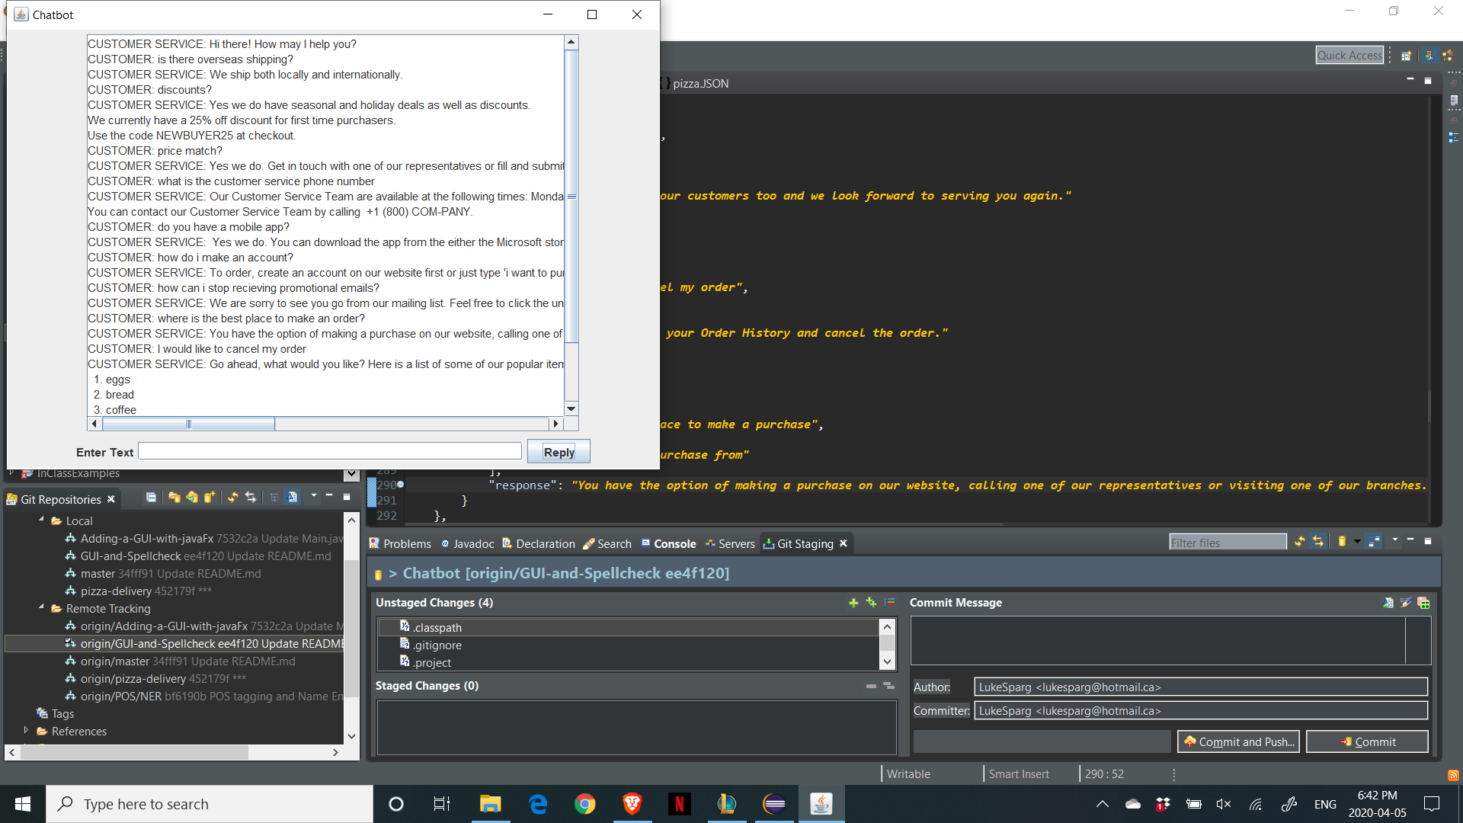

When it doesn’t understand the input:

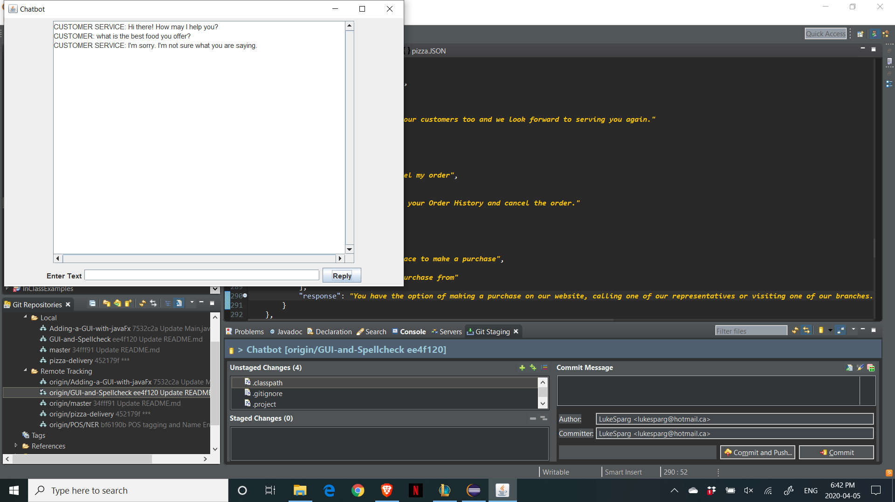

**Features:**

**Addition of pizza delivery topic:**

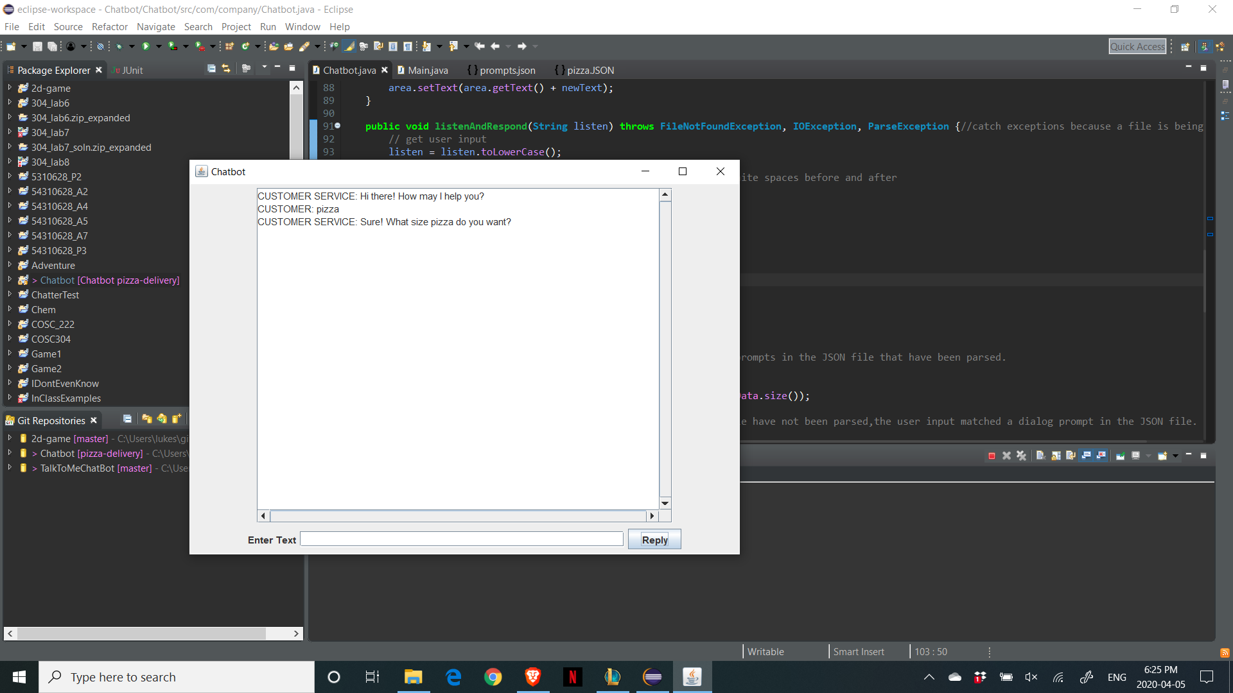

**Spell Checking:**

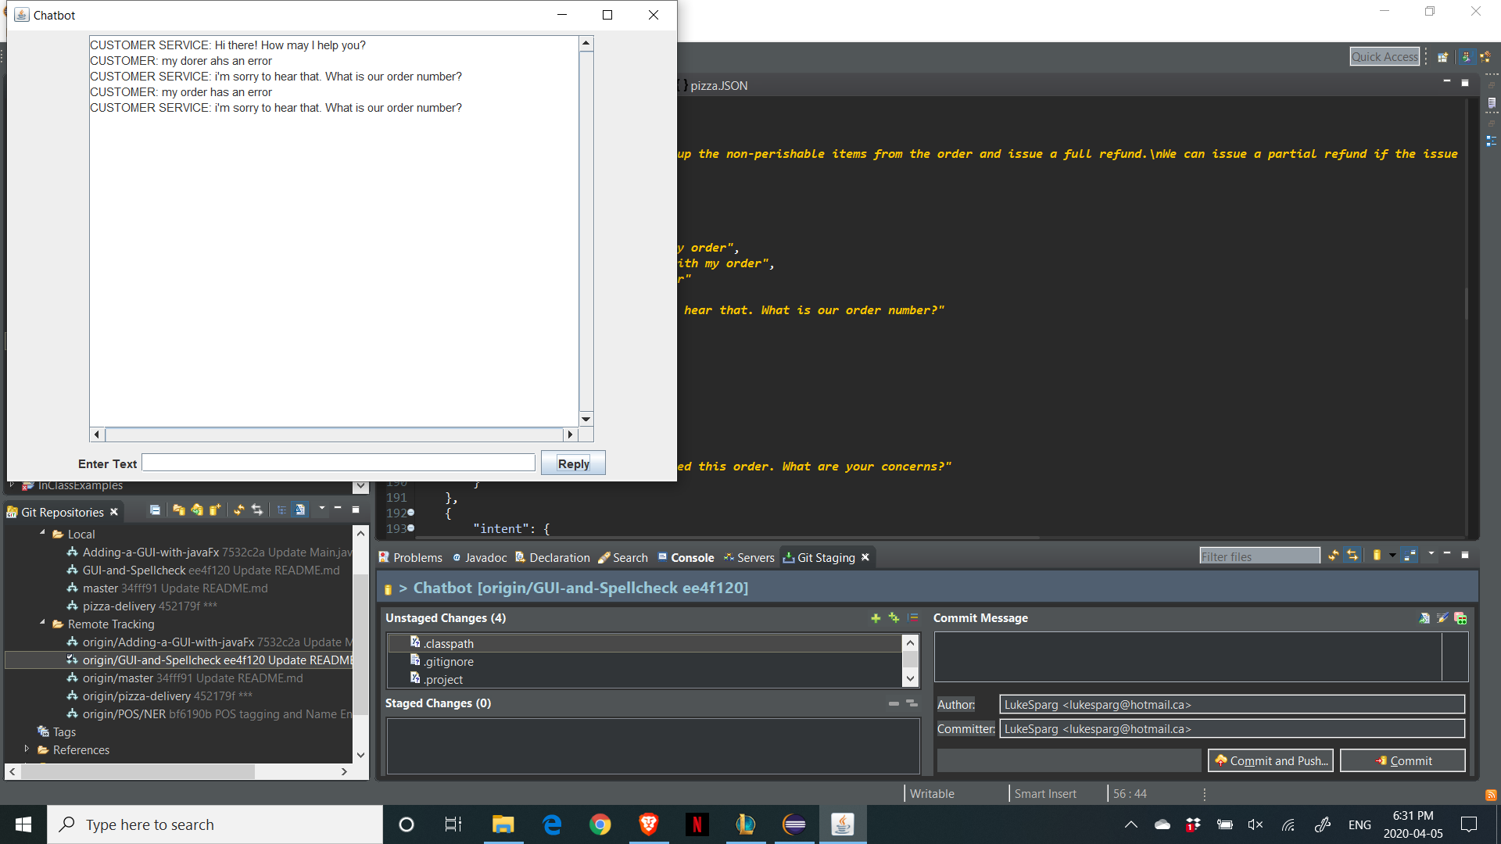

**Different error messages:**

